

Guidelines on
Format, Duplication & Publication
for the
PhD Dissertation

Office of the Associate Dean for Graduate Academics
JB 158
January 2016 Version
Table of Contents

A. INTRODUCTION 1
B. THE STANDARD FORMAT 1
C. THE PRELIMINARIES 2
D. THE BODY 9
E. NUMBER OF COPIES REQUIRED 9
F. COPYRIGHT AND BINDING 10
G. SUBMISSION OF BOUND COPIES 14
H. PUBLICATION 14
I. SPECIAL DUTIES 15

List of Figures

Figure 1: Standard Format of Cover Page for Ph.D. Dissertation 5
Figure 2: Standard Format of Title Page for Ph.D. Dissertation 7
Figure 3: Guidance Committee Signature Page 9
Figure 4: Standard Format of Abstract 12
Figure 5: Standard Sequence of Sections for Ph.D. Dissertation 14
Figure 6: Format of Front Cover and Spine of Ph.D. Dissertation 20

List of Tables

Table 1: Degree Titles for Cover and Spine of Ph.D. Dissertation 21

NOTE
If any questions arise, kindly inquire at this office:

Contact Prof. Jose Ulerio  Rogers Hall Room 412A  Tel. 646.997.3178  Fax: 646.997.3433  Email: julerio@nyu.edu | or the Office of the Associate Dean for Graduate Academics located in JB158

INTRODUCTION

The purpose of this document is to state the formal requirements which must be met by NYU Tandon School of Engineering students who are required to submit a bound Ph.D. Dissertation to qualify for the Ph.D. degree, as described in the NYU Tandon School of Engineering bulletin for a particular academic program.

A dissertation is basically composed of two parts: the preliminaries and the body. Details regarding the format and content of each of these sections as well as the methods of duplication and binding are described in the contents of this document.

THE STANDARD FORMAT

The thesis is to be printed single-sided on standard 20-lb. 8½” x 11” letter size white, high-quality, photocopy paper with crisp, dark black characters.

Margins settings should be no less than the following:

Left margin (binding edge): 1½”
Right margin (Outer edge): 1”
Top margin (except for page number): 1”
Bottom margin: 1”

The document, with margins as specified above, can either be one-and-a-half (1-½) or double spaced, using 12 point Arial or Times Roman style font. Footnotes and short quotes may be single-spaced with a double space, every 5 lines as an eye guide.

Drawings, graphs, and other illustrations should be of the same size as the dissertation paper pages and numbered consecutively with the pages of the Body.

Mathematical or chemical equations must be typed (not hand written). Drawings/Illustrations and diagrams should conform to good drafting practice.

Photographs may be used where desirable. Full-page photographs may be bound in with the dissertation. Larger drawings or figures may be placed in a pocket at the back inside cover, provided by the Bindery.

THE PRELIMINARIES

All dissertations must contain the following standardized preliminaries in the order of listing.

  - Cover Page: Standard format for the cover page is shown in Figure 1. The date appearing on the cover page should be the month and year of the expected degree award date and not the completion date of the work (e.g., January 20XX or May 20XX or September 20XX). This page represents the cover of your bound document. Black cover with gold letters.

  - Title Page: Similar to the cover page above except that it includes the signature of the department chair to be placed on the lower right-hand side. On the lower left-hand section of the title page you should also include your University ID number. You are required to submit four (4) bound copies of your dissertation with the original signature of the department chair. Standard format for the title page is shown in Figure 2.

  - A copyright Page: Refer to Copyright Section in case copyright is applied for. Typically copyrighting of dissertation is not recommended. However, you should always consult with your dissertation advisor before making a final decision. You may also refer to UMI’s web site for more information.

  - Guidance Committee Signature Page: Refer to Figure 3. This is the very first page to be numbered. Note that the preliminaries are numbered with small Roman Numerals (e.g., i, ii, iii, etc).

  - A Microfilm/Publishing Page: Include the following statement on this page:

Microfilm or copies of this dissertation may be obtained from:

UMI Dissertation Publishing
ProQuest CSA
789 E. Eisenhower Parkway
P.O. Box 1346
Ann Arbor, MI 48106-1346

DISSERTATION TITLE

DISSERTATION

Submitted in Partial Fulfillment of

the Requirements for

the Degree of

DOCTOR OF PHILOSOPHY (Degree Title)

at the

NEW YORK UNIVERSITY
TANDON SCHOOL OF ENGINEERING

by

Author’s Name

January or May or September 20XX

Figure 1: Standard Format of Cover Page for Ph.D. Dissertation

DISSERTATION TITLE

DISSERTATION

Submitted in Partial Fulfillment of

the Requirements for

the Degree of

DOCTOR OF PHILOSOPHY (Degree Title)

at the

NEW YORK UNIVERSITY
TANDON SCHOOL OF ENGINEERING

by

Author’s Name

January or May or September 20XX

Approved:
Department Chair Signature
Date

University ID: | N########

Net ID:

Figure 2: Standard Format of Title Page for Ph.D. Dissertation

ii
Approved by the Guidance Committee:

Major: | Chemical Engineering
Advisor’s Name
Professional Rank
 |  | Date
Advisor’s Name
Professional Rank
 |  | Date
Advisor’s Name
Professional Rank
 |  | Date
Minor: | Petroleum Engineering
Advisor’s Name
Professional Rank
 |  | Date
Advisor’s Name
Professional Rank
 |  | Date

Figure 3: Guidance Committee Signature Page

  - Vita Page: Give date and place of birth and a brief educational and professional history. Clearly state period of time devoted to the research or project, the laboratories in which it was performed, and the source of any special support (research contract, research grant, fellowship, assistantship, traineeship, etc.). A vita page is not the same thing as a resume.

  - Acknowledgment Page: (optional). You may include a brief acknowledgment to those that provided assistance and/or support. This section is optional and is limited to one page in length.

  - Dedication Page: (optional). You may include a brief dedication of your work. This section is optional and is limited to one page in length.

  - Abstract: State the purpose and significance of the investigation being reported and major conclusions. The special caption/header for the abstract is shown in Figure 4.

  - Table of Contents: List the page number upon which each major division of the dissertation begins. Subdivisions may also be included. Appendices should all be listed by title, along with page number on which each begins.

  - List of Figures. List the title and page number of each figure and graph/illustration. This section may be included as part of the Table of Contents. The List of Figures may be omitted if the total number of figures and graphs does not exceed ten.

  - List of Tables. List the title and page number of each table. This section may be included as part of the Table of Contents. The List of Tables may be omitted if the total number of tables does not exceed ten.

The preliminaries section page numbers are numbered with small Roman Numerals (e.g., i, ii, iii, etc.). Note that the title page is not numbered. Refer to Figure 5. THE GUIDANCE COMMITTEE SIGNATURE PAGE IS THE FIRST PAGE TO BE NUMBERED, NOT WITH “i” BUT WITH “ii”.

ABSTRACT

DISSERTATION TITLE

by

John Doe

Advisor: Prof. Jane S. Smith, Ph.D., P.E.

Submitted in Partial Fulfillment of the Requirements for

the Degree of Doctor of Philosophy (Degree Title)

January or May or September 20XX

A survey of the literature shows that transportation has played a pivotal role in the United States as a form of ……

Figure 4: Standard Format of Abstract

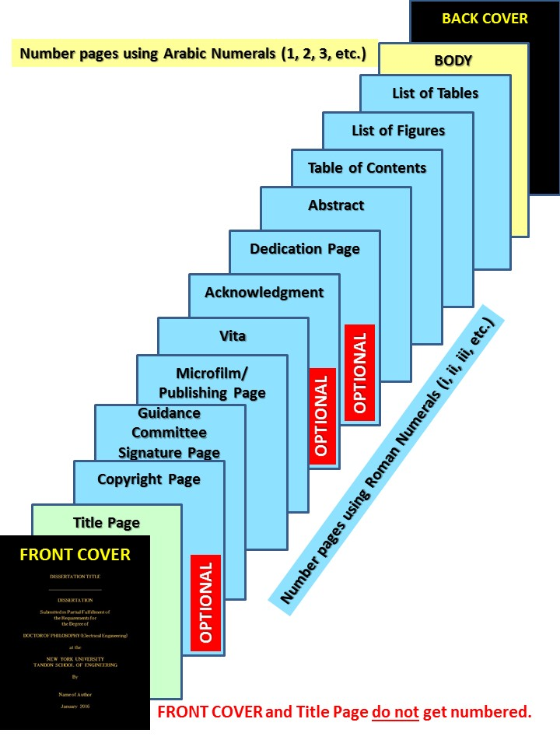

Figure 5: Standard Sequence of Sections for Ph.D. Dissertation

THE BODY

- Style: There are no general faculty rules regarding the outline to be followed in the composition of the manuscript, the style of exposition, and the extent to which tables of data, graphs, and other illustrations are used. The major academic department is the responsible judge of the adequacy of the manuscript as an account of the research performed. Please consult with your dissertation adviser.

- Arrangement: The sub-division of the body of the manuscript is largely left to the student. Suitable headings of the sections are essential for the guidance of the reader. A moderate use of footnotes or appendices may allow details to be taken out of the main text which would otherwise obstruct the even flow of the presentation. A bibliography is required.

- Bibliography: The aim of the bibliography is twofold: to list introductory or further reading and to connect the research with similar work. All the papers and books to which references appear in the text should be listed in the bibliography numbered sequentially. References in the text to publications are made by the number (typically displayed in parentheses) of the entry in the bibliography. Whenever extensive use is made of published material which is copyrighted, the student should obtain written permission for its use.

- Index: (optional). An index may be included if desired.

- Numbering of Pages: The pages of the BODY are numbered at the top outer edge of the text, but at least one-half inch below the top of the page, except on pages having a display heading where the numbers may be at the bottom center. Each page, including pages in any appendices, is numbered with Arabic numerals (1, 2, 3, etc.). If it is inconvenient to insert a number on a page (for example, on a page with a photograph) then the page is counted anyway as if the number had been written on it. Division Title pages are also numbered with Arabic number.

NUMBER OF COPIES REQUIRED

Four (4) bound copies of the final version of the dissertation must be submitted. The copies must include the original department chair signature as well as the original Guidance Committee signatures.

The student must obtain the necessary original signatures in black ink for both the title page as well as the guidance committee signature pages. Please prepare five (5) original copies of these pages; one (1) to be submitted to the Graduate Academics office (Prof. Jose Ulerio – RH412A), the other four (4) to be bound with the original manuscript.

In case a sponsor has supported the research and requires one (1) or more copies of the document under the terms of support, the number of copies required is correspondingly increased. If more than one faculty member has played a major role in the direction of the research, either informally or as a co-advisor, and desires a copy of the dissertation, an additional bound copy should be made for him/her.

COPYRIGHT AND BINDING

- Copyright: Before publishing, the doctoral candidate must decide if he/she wishes to use the services of UMI Dissertation Publishing (Proquest) to obtain a copyright. This service is principally of interest to students of the Humanities. Scientific dissertations are seldom copyrighted, and the doctoral candidate is in general advised not to do it. Copyright may bar publication in certain scientific journals.

If, however, copyright is desired, then the copyright page should read:

Copyright by

John Doe (full legal name of author)

20##

There is an extra charge for the copyright service. This is explained in the AGREEMENT FORM of UMI (refer to the UMI web site for more information).

- Binding: The required four copies of the dissertation shall be bound in cloth of textbook quality (commercial C grade). Candidates will arrange for binding themselves and are responsible for any costs associated with the binding.

To assure uniformity in binding and lettering, the following standard is prescribed:

Binding Cover | Lettering
Black | Gold

The format of the front cover and spine is illustrated in Figure 6.

The date printed on the front cover should always correspond to the month and year of the expected degree award. In addition, the binding on the spine shall be stamped with the candidate's last name, the title of the document in abbreviated form if necessary, and the abbreviation of the degree and year. When the bound copy is standing with the title cover to the right, the spine data should read downward. Refer to Table 1 for a list of degree titles for use on cover and spine.

The student should prepare for the Binder on a separate sheet of paper the exact wording of the abbreviated material to appear on the spine. A maximum of 60 characters including spaces can be accommodated.

You are free to have your dissertation bound by any Bindery. However, a bindery that is accustomed to meeting NYU Tandon School of Engineering’s requirements and is relatively close to Downtown Brooklyn is:

Henry Bookbinding Company  135 Henry Street (Basement)  New York, New York 10002  Tel. (212) 962-1977 | Hours of Operation:  Sunday – 8:30 a.m. to 4:30 p.m.  Monday thru Thursdays - 8:30 a.m. to 4:30 p.m.  Fridays - 8:30 a.m. to 12:30 p.m.

Directions: Take the F train at Jay Street towards Manhattan (take middle car) to East Broadway (two stops from NYU Tandon School of Engineering). Henry Bookbinding is less than half (½) a block away; it is located between Pike Street and Rutgers Street. The Bindery should be allowed at least four (4) working days to avoid extra charges. We also recommend that you contact them prior to your visit to the Bindery.



Figure 6: Format of Front Cover and Spine of Ph.D. Dissertation

Table 1: Degree Titles for Cover and Spine of Ph.D. Dissertation
On Title Page and On Front Cover of Binding | On Spine of Binding
Doctor of Philosophy (Biomedical Engineering) | PH.D. (Biomed)
Doctor of Philosophy (Chemical Engineering) | PH.D. (Ch.E.)
Doctor of Philosophy (Civil Engineering) | PH.D. (C.E.)
Doctor of Philosophy (Computer Science) | PH.D. (Comp.Sc.)
Doctor of Philosophy (Electrical Engineering) | PH.D. (E.E.)
Doctor of Philosophy (Materials Chemistry) | Ph.D. (Mat.Chem.)
Doctor of Philosophy (Management of Technology) | PH.D. (Mgt. of Tech.)
Doctor of Philosophy (Mathematics) | PH.D. (Math.)
Doctor of Philosophy (Mechanical Engineering) | PH.D. (M.E.)
Doctor of Philosophy (Physics) | PH.D. (Phys.)
Doctor of Philosophy (Transportation Planning & Engineering) | PH.D. (T.P.&E.)

SUBMISSION OF BOUND COPIES

Consult your academic advisor for guidance on when your dissertation in final manuscript form is to be submitted for review and grading. You should consult with your dissertation advisor to schedule a formal defense of your dissertation.

Prior to printing for binding it is highly recommended that the student submit an electronic version of the document to assure that it conforms to the University guidelines. You may email the document to Prof. Jose Ulerio (julerio@nyu.edu) in PDF format.

The final bound and signed copies must be submitted by the student to Prof. Jose Ulerio (RH412A). At the start of each semester Email notifications are sent to all students regarding the submission deadline. You should plan accordingly to meet the deadline.

The four (4) bound copies will be distributed as follows:

Copy # 1 – Dissertation Advisor (and co-advisor(s))
Copy # 2 – Student’s Academic Department
Copy # 3 – Bern Dibner Library of Science and Technology
Copy # 4 – The student retains the last copy

PUBLICATION

The University urges publication of all doctoral dissertations in a recognized technical or scientific journal. Specific requirements may be imposed by individual departments. The title of the printed article must be footnoted with the "submitted" phrase used in the dissertation as follows:

"Taken from the dissertation submitted to the Faculty of the New York University Tandon School of Engineering in partial fulfillment of the requirements for the degree Item A, Item B.”
Item A (type in full description of degree)
e.g. Doctor of Philosophy (Degree Title)

Item B (type in degree award date)
e.g. January or May or June 20XX

The doctoral publication requirement is fulfilled by the electronic submission to Proquest, but publication in print as described above is also urged. The publication should represent the substance of the dissertation to an extent satisfactory to the department involved. Occasionally more than one (1) article is warranted.

Publication as a jointly authored paper is allowed and the thesis advisor is frequently a co-author.

SPECIAL DUTIES

  - Each candidate is responsible for arranging the final dissertation defense at a time convenient to members of the Guidance Committee. Students are required to submit the Request to Schedule Dissertation Defense for the PhD Degree form to the Office of Graduate Academics (see Prof. Jose Ulerio in RH412A) at least 10 days prior to the examination date. An announcement to the academic department will be issued by the Office of Graduate Academics provided that admission to candidacy has been satisfied as well as major and minor requirements.

  - Each candidate should appear at the final dissertation defense with four (4) unbound copies. These copies must be approved by members of the Guidance Committee prior to the defense. Subsequently, each candidate must personally take the four (4) bound copies and the fifth title and signature pages to members of the Guidance Committee for the requisite signatures.

  - Each student is required to upload their final dissertation to Proquest.

  - Each student is required to complete the SURVEY OF EARNED DOCTORATES for the Office of National Opinion Research. The survey can be completed at the NORC website. Select New York University as the school.

There may be more than three (3) members, in which case add more lines.
Examples: Professor of Chemical Engineering Associate Professor of Chemistry

